SPARC Mission

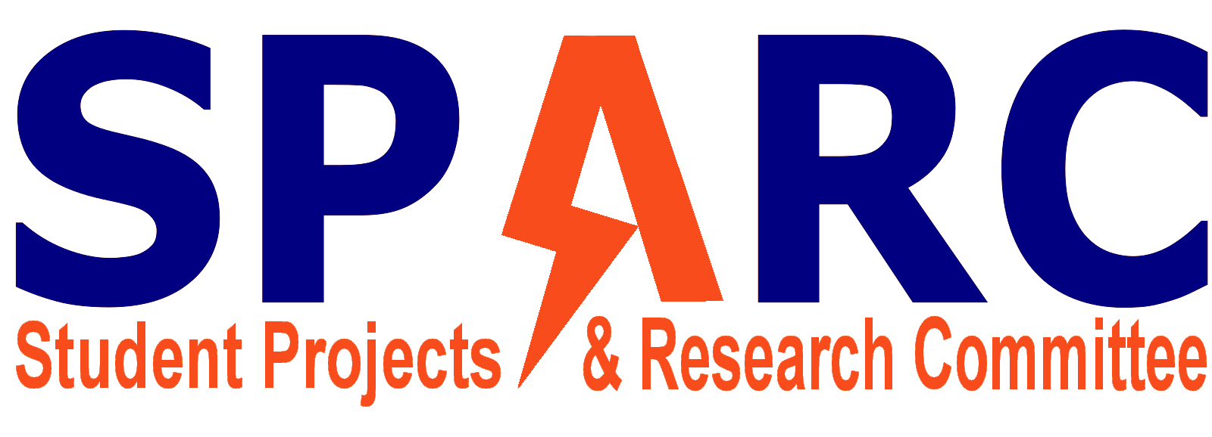

# Vision

To create and foster an environment of creativity and innovation for students at Auburn University. No matter their major, the students should only need a willingness to learn and grow to participate in an experience that will produce men and women that will become extremely valuable in the workforce.

# 2018 Goals

* Maker Training Session
  + Will teach the next generation of SPARC members.
  + Intended primarily for new members but open to existing members
  + YouTube Tutorial videos for small, easy projects
  + A weekly “maker” meeting that discusses the new member project
  + A meeting that describes how to start a project with SPARC
  + A “new member” project
    - Offer kits for members to buy
* At least 3 consistent projects with 3 or more members each that meet at least weekly with unique members working on them
* E-Day Spring 2018 - 3 projects
* A full committee competition
* Promotion of SPARC for a growth of 5+ active members a year
  + New flyers that promote new makers
  + Attend Dr. Roppel’s events
  + Professor relations